DoggyFeed User Manual
Nov 3, 2026 · @Radovan Dobrík

1. Introduction
DoggyFeed plans what your dogs eat: it works out each dog's daily energy need, fills each bowl to that target from your own food library, and keeps a record of what was served. It runs in a web browser on a phone, tablet or computer.
What you can do with it
- Keep a profile for every dog: weight, desired weight, life stage, activity, meals per day and photo.
- Keep a library of foods with energy, protein, fat and fiber per 100 g, portions, stock, pictures and shop links.
- Fill each dog's bowl in the Meal planner and see the totals against the dog's energy target.
- Save bowls as reusable plans, record served bowls and look back at them in Bowls history.
- Keep a calendar of vet visits, grooming and other events, with reminders.
- Share one dog house with family members, with full or view-only (guest) access.
How your data is stored
All data belongs to a dog house: a household with its own dogs, foods, bowls, plans, calendar and users. Everything is saved on the DoggyFeed server in a MariaDB database, so every user of the dog house sees the same data on every device. Users of one dog house never see another dog house's data.
Languages
The app is available in English, Czech (Čeština) and Polish (Polski). Choose the language at the top right of the page or on the sign-in screen. Dates and times follow the chosen language. Names and other data you type in are never translated.
DoggyFeed is a planning aid, not veterinary advice. The energy targets are rough estimates, and the sample foods are examples: check nutrition values against the package or a trusted database.

2. Getting started
You need a user in a dog house to use DoggyFeed. Either someone adds you to their dog house, or you create a new dog house yourself.

2.1 Sign in
Open the DoggyFeed address in your browser. Enter your Username and Password and press Sign in. The language picker above the form switches the page language before you sign in.
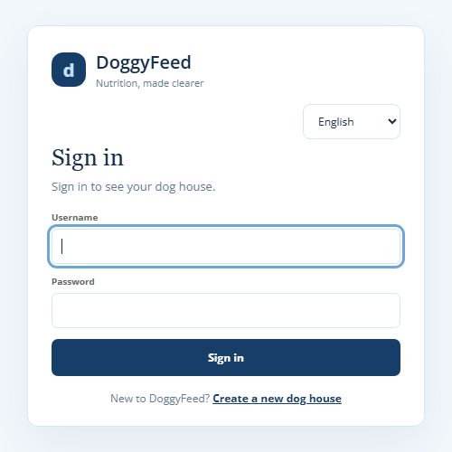
A session lasts 30 days from its last use, so you stay signed in on your own devices. Use Sign out in the menu on shared computers.

2.2 Create a new dog house
On the sign-in screen, choose Create a new dog house. Fill in the form and press Create dog house. You become the first user of the new dog house.
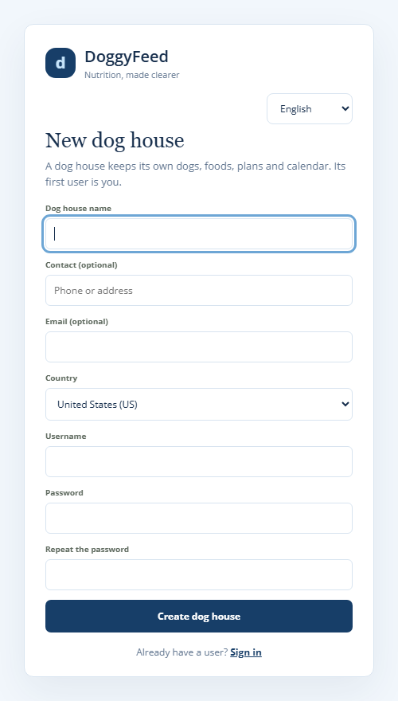
Field | Required | Example | Notes
Dog house name | yes | Novák family | Shown at the top of every page
Contact | no | +420 777 123 456 | Phone or address
Email | no | family@example.com
Country | yes | Czechia (CZ) | Pre-filled from your browser's language; used for food searches and imports
Username | yes | radek | Unique across all dog houses
Password / Repeat the password | yes | at least 8 characters | Stored only as a secure hash
The form is protected against automated sign-ups. If you send it within a few seconds of opening it, or try many times in a row, it asks you to wait and try again.

2.3 The Welcome page
A new dog house starts with sample dogs and foods, so you can try every function at once. The first time it opens, DoggyFeed shows the Welcome page with three setup steps.
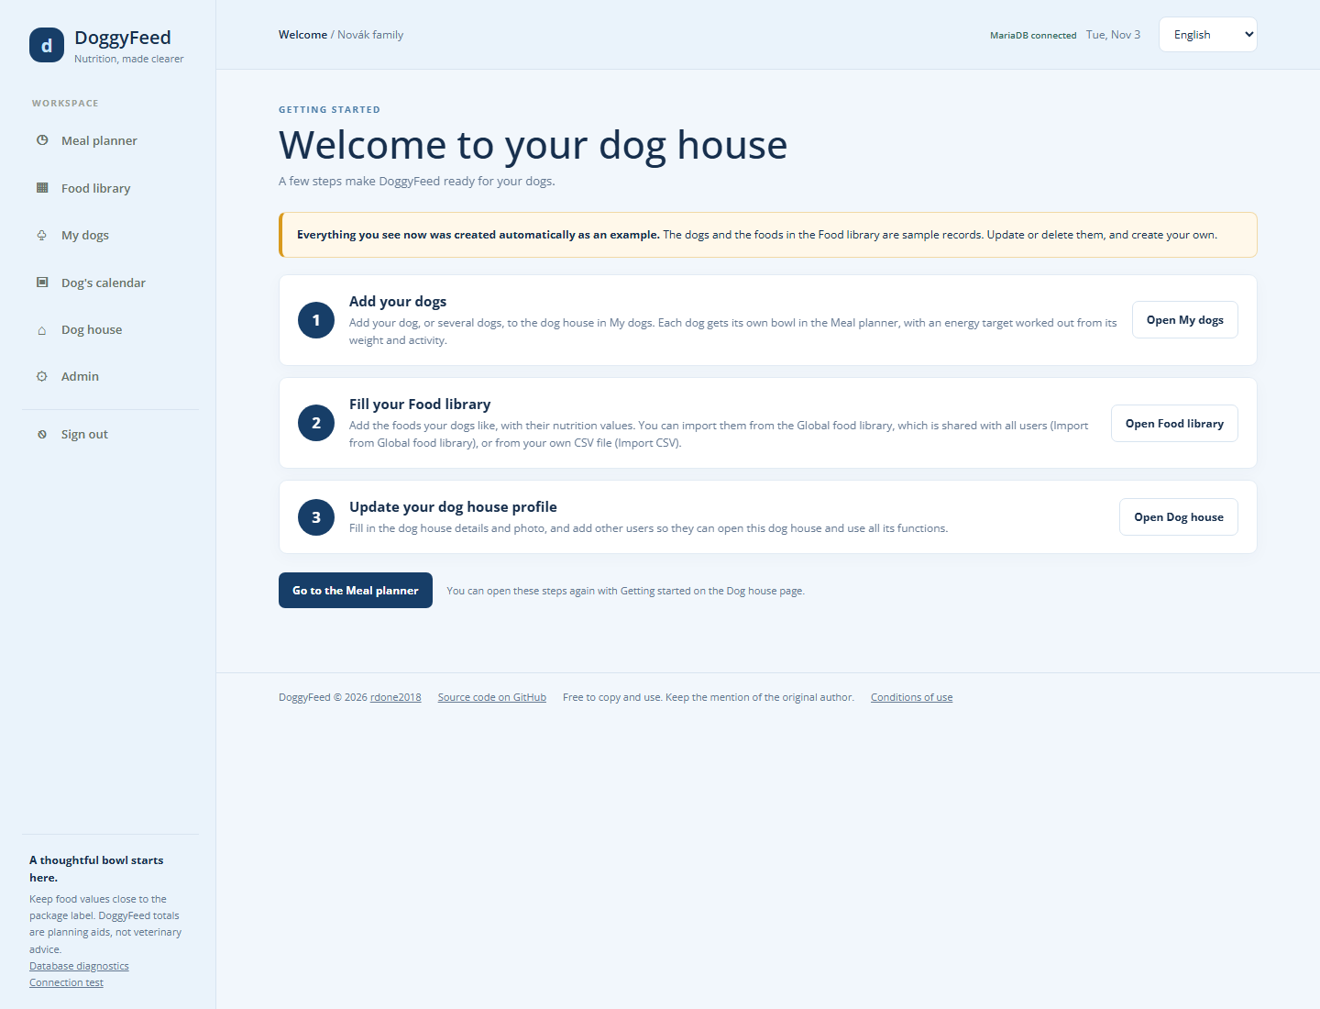
- Add your dogs in My dogs. Each dog gets its own bowl in the Meal planner, with an energy target worked out from its weight and activity.
- Fill your Food library with the foods your dogs eat. Import them from the shared Global food library, from a CSV file, or search the web.
- Update your dog house profile: details, photo, and other users who should share this dog house.
Update or delete the sample records, then press Go to the Meal planner. You can open the Welcome page again any time with Getting started on the Dog house page.

2.4 Roles
Every user belongs to exactly one dog house and has one of three roles.
Role | Can see | Can change | Typical user
User | Everything in the dog house | Everything in the dog house, including its users | Family members who feed the dogs
Guest | Everything in the dog house | Only their own password | A dog sitter or relative who only looks
Administrator | Everything in the dog house, plus the Admin console | Their dog house, plus all dog houses, users, the Global food library and countries | Whoever runs the DoggyFeed server
A guest sees the badge Guest · view only at the top of the page. Buttons that change data are hidden, and amounts and stock fields are read-only.

3. Screen layout
Every page has the same frame: the menu on the left, a top bar, the page content and a footer. On a phone the menu becomes a row of tabs at the top of the page.
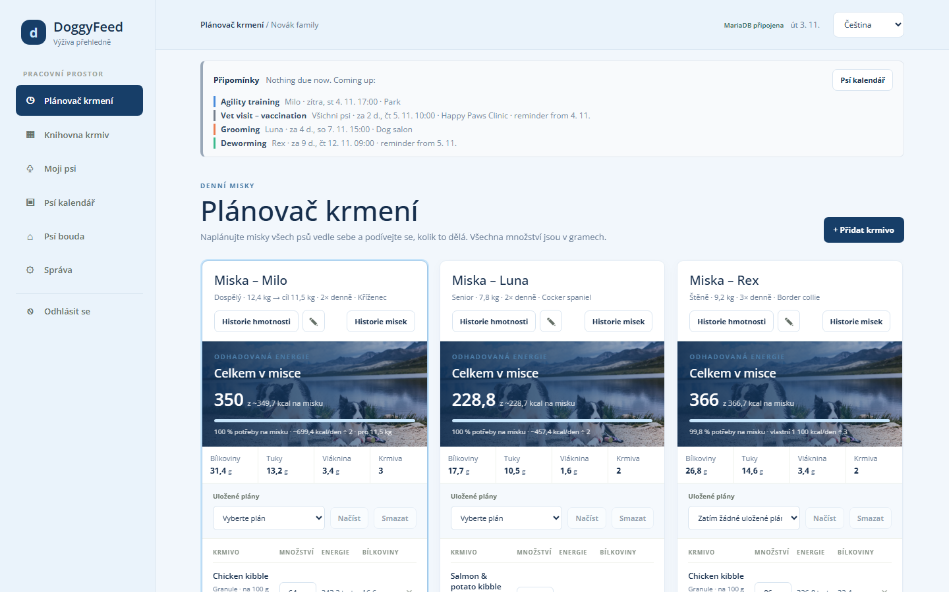
Part | What it shows
Menu (left) | Meal planner, Food library, My dogs, Dog's calendar, Dog house, Admin (administrators only) and Sign out
Top bar | The page name and dog house name, the connection status, today's date and the language picker
Connection status | MariaDB connected when saves reach the server; Saving… while a save runs; Browser storage only or Database save failed when the server cannot be reached
Reminders ribbon | Events that are due or start today, then the next upcoming events (Meal planner and My dogs only)
Messages | Short confirmations at the bottom of the screen, such as "Food saved to database"
Footer | Copyright, a link to the source code on GitHub and the conditions of use
Sidebar note (administrators) | Links to Database diagnostics and the Connection test
Saving. Every change is saved to the server automatically; there is no Save button for the page as a whole. While a page is idle, it checks for changes made in another window or device every 30 seconds and loads them.
Banners. Two banners can appear at the top of a page:
- Changes were made somewhere else: the same dog house was changed on another device at nearly the same moment. Choose Load the latest data to see the newest data, or Save my version anyway to keep yours.
- Restart the DoggyFeed server: the server was updated but not restarted. Ask whoever runs the server to restart it.

4. Meal planner
The Meal planner shows one bowl per dog, side by side, and fills each bowl to that dog's energy target per meal. It is the page DoggyFeed opens on.
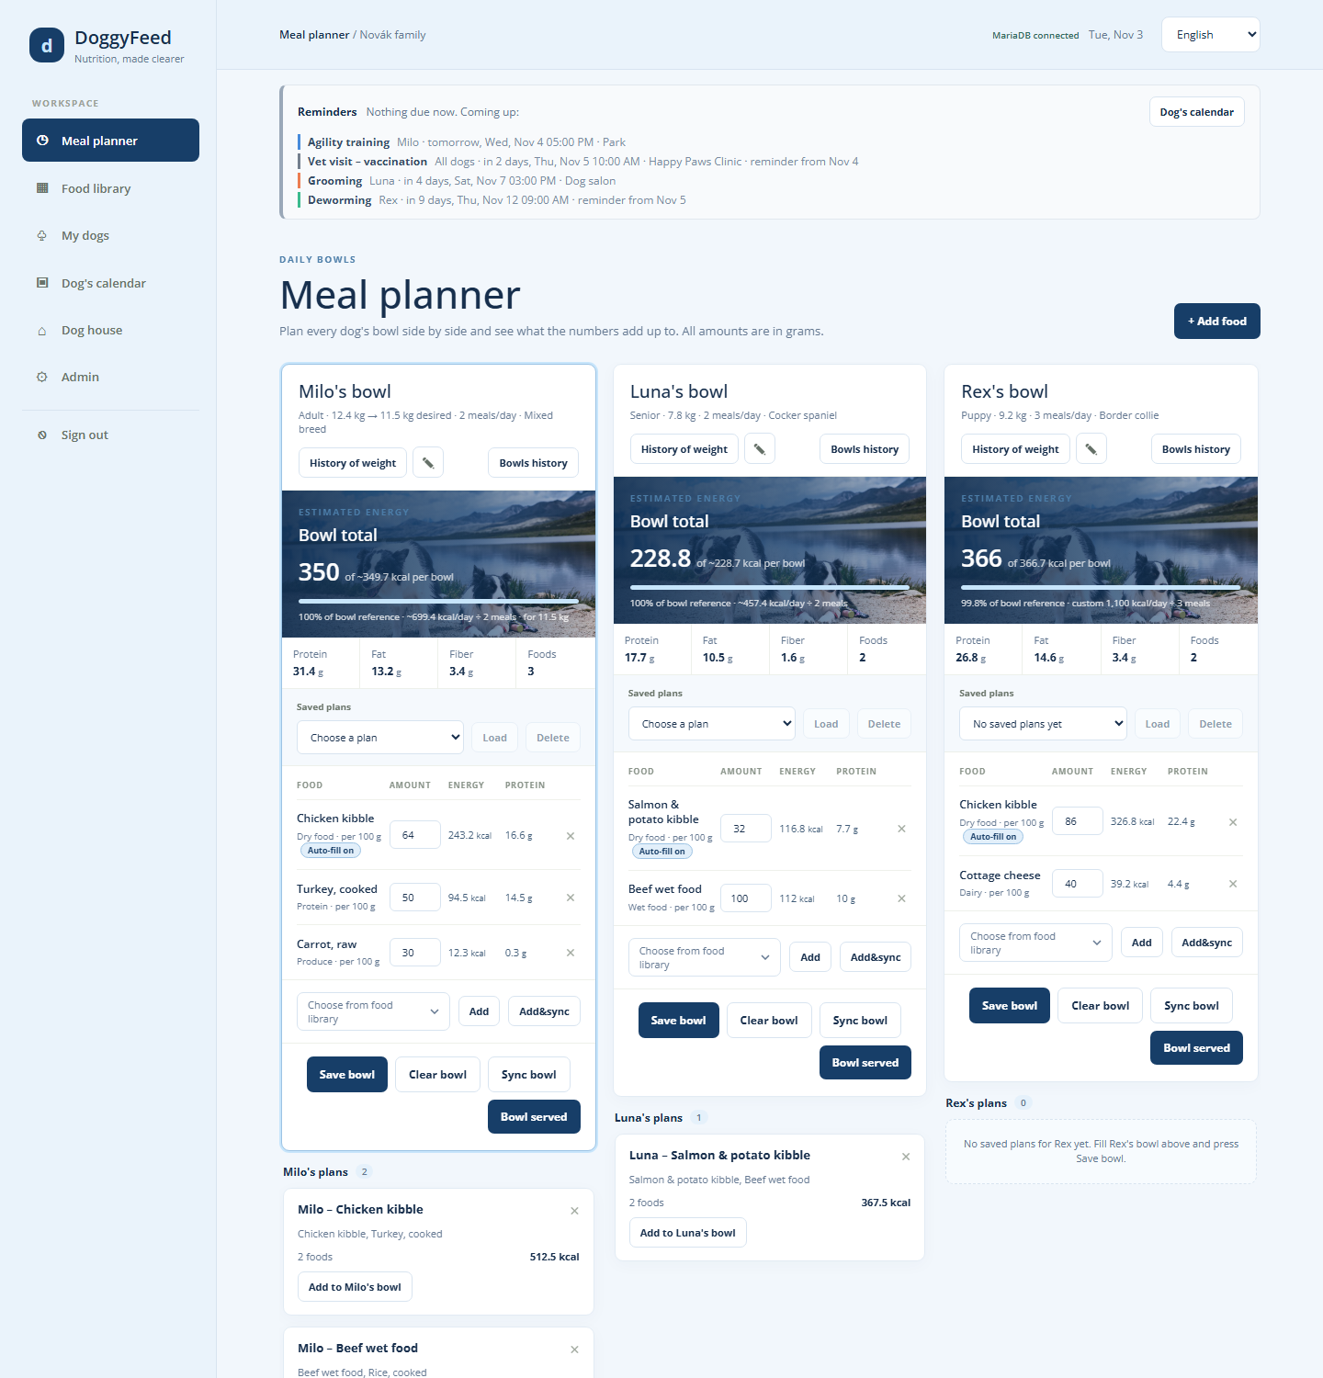

4.1 A dog's bowl
Each bowl card has, from top to bottom:
- Header: the dog's name, life stage, weight (and desired weight), meals per day and breed, with buttons for History of weight, editing the dog (pencil) and Bowls history.
- Estimated energy: the bowl total in kcal against the target per bowl, a progress bar and how the target was worked out, over the dog's photo.
- Totals: protein, fat and fiber in grams, and the number of foods.
- Saved plans: a list of this dog's plans with Load and Delete.
- Food rows: each food with its amount in grams, energy and protein. × removes a food.
- Add a food: choose from the food library, then Add or Add&sync.
- Bowl buttons: Save bowl, Clear bowl, Sync bowl and Bowl served.

4.2 Adding foods and amounts
Choose a food in Choose from food library and press Add. How much is added depends on the food:
Food | Amount added | Example
Has a portion | One portion; adding it again adds another portion | Turkey, cooked: 50 g
Dry food, or no portion | Auto-filled to the energy still missing in the bowl | Chicken kibble: 64 g
No energy value | 100 g
Type an amount in the Amount field to change it. The totals update as you type.
Auto-fill. A food marked Auto-fill on fills the energy the other foods leave below the bowl target. When several foods are auto-filled, they share that energy equally. Typing an amount for the food, or clicking its Auto-fill badge, switches auto-fill off for it.
Example. Milo's target is 349.7 kcal per bowl. Turkey (50 g) gives 94.5 kcal and carrot (30 g) gives 12.3 kcal, together 106.8 kcal. Auto-fill gives chicken kibble the remaining 242.9 kcal: 242.9 ÷ 3.80 kcal per g = 64 g.

4.3 Working with several dogs
- Add&sync puts the chosen food into every dog's bowl at once. Auto-filled foods are worked out separately for each dog's target.
- Sync bowl replaces every other dog's bowl with a copy of this bowl. Foods with a portion keep their amounts; Dry food and foods without a portion are auto-filled to each dog's target.
- + Add food at the top of the page jumps to the food picker of the selected bowl.

4.4 Saved plans
A plan is a saved copy of a bowl, to reuse later.
- Save bowl saves the bowl as a plan named after the dog and its first food, for example "Milo – Chicken kibble". Saving again with the same name asks whether to replace the plan.
- Load (in the bowl) replaces the bowl with the chosen plan.
- Add to Milo's bowl (on a plan card under the bowl) adds the plan's foods to what is already in the bowl. You can also drag a plan card onto the bowl.
- Delete or × on a plan card deletes the plan.
Each dog's plans are listed right under its bowl. Plans of a dog that was removed are listed at the bottom as plans for any dog.

4.5 Recording a served bowl
Press Bowl served when the dog gets its bowl. DoggyFeed records the bowl with the current time, its foods and amounts, and shows it in Bowls history (section 7). It also takes the used pieces off each food's stock (section 6.3).
Clear bowl empties the bowl without recording anything.

5. My dogs
My dogs holds one card per dog with its details, its daily energy target and its next events. Each dog you add gets its own bowl in the Meal planner.
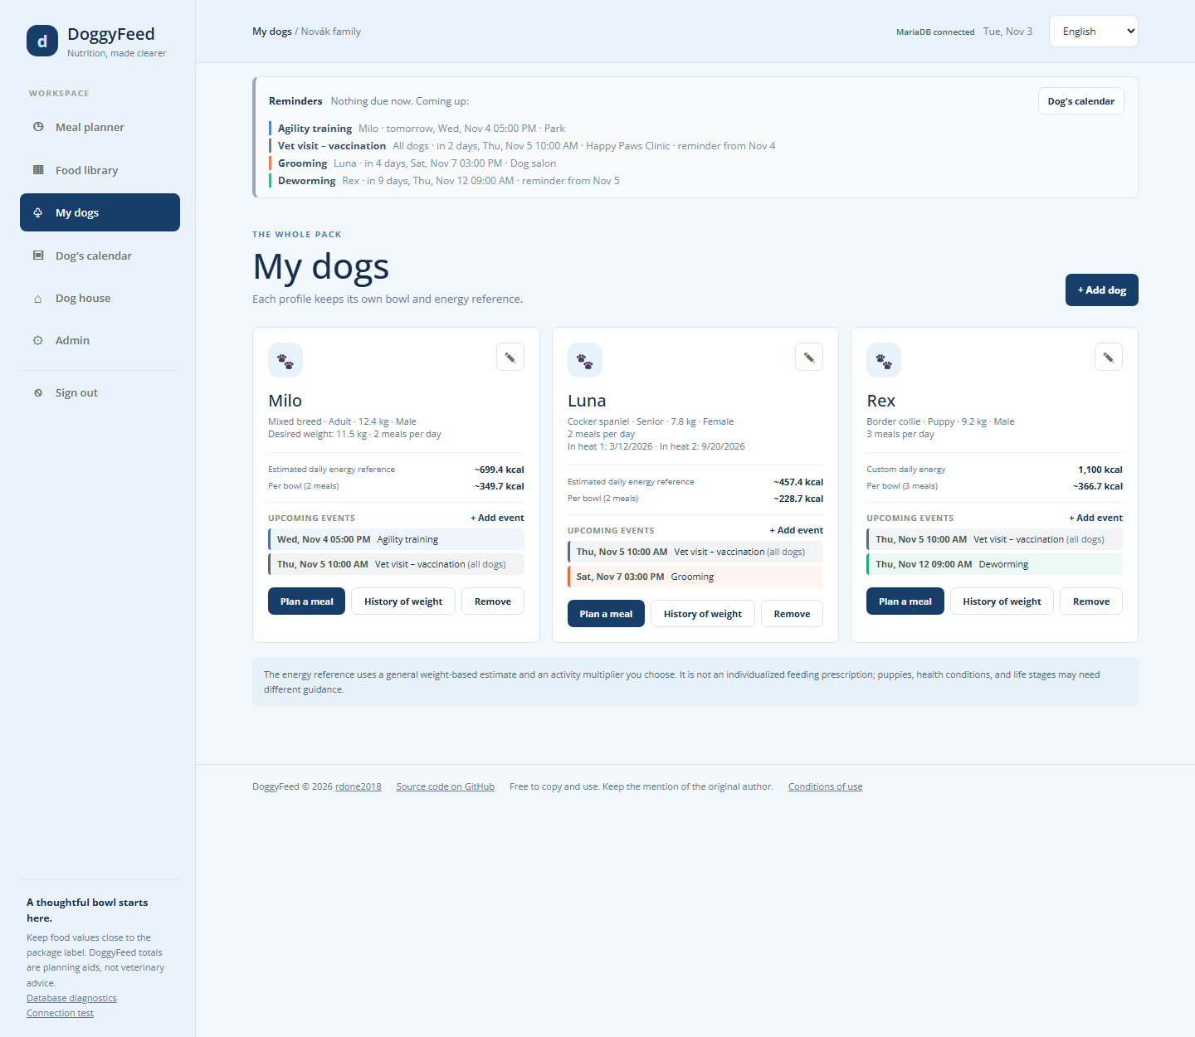
Each card shows the dog's photo, breed, life stage, weight, gender and meals per day, then:
- Estimated daily energy reference (or Custom daily energy) and the energy Per bowl.
- Upcoming events: the next three events within 60 days, for this dog and for all dogs. + Add event adds one for this dog.
- Plan a meal opens the Meal planner with this dog selected; History of weight opens the weight history; Remove deletes the dog.

5.1 Adding or editing a dog
Press + Add dog, or the pencil on a dog's card. Fill in the form and press Save (or Save changes).
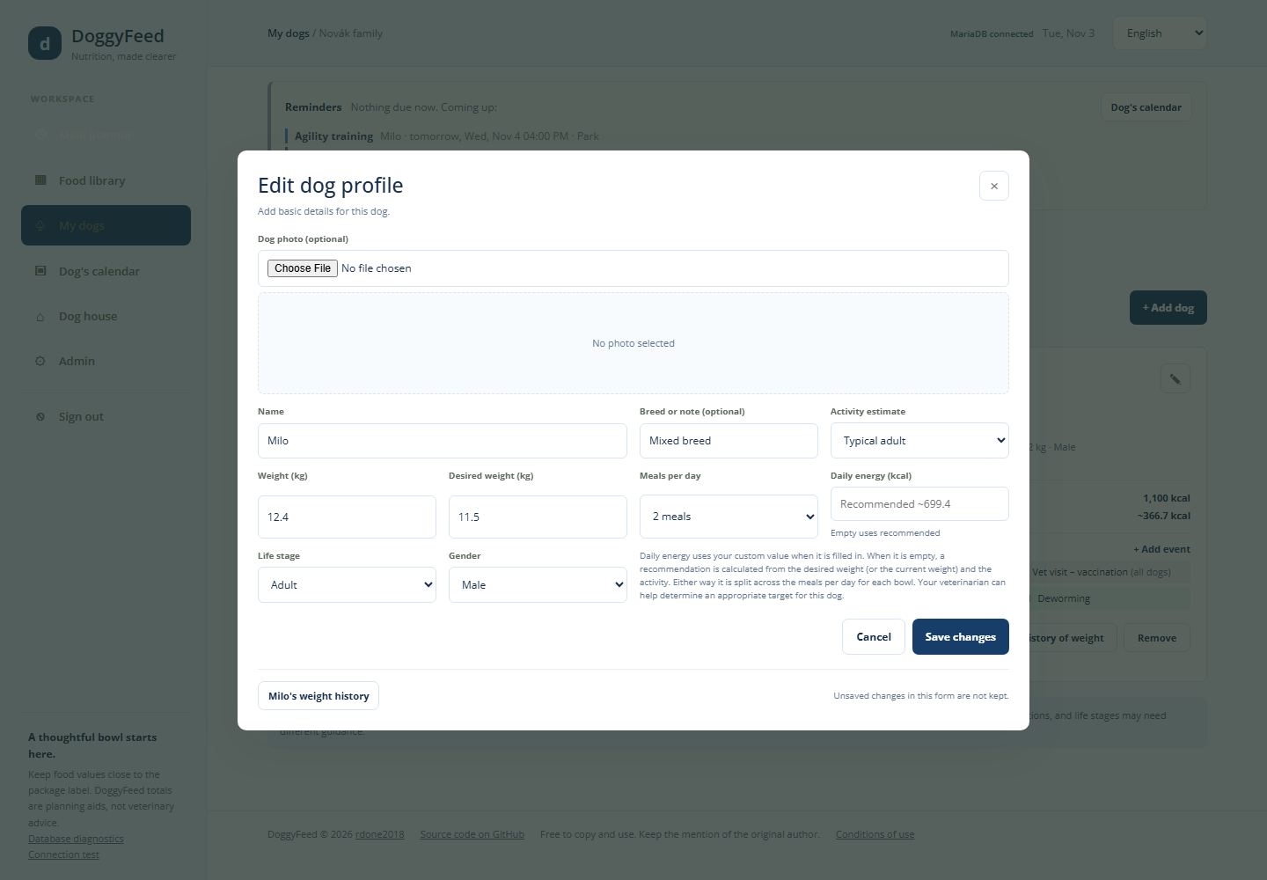
Field | Values | Example | What it does
Dog photo | JPG, PNG or WebP, up to 8 MB |  | Shown on the dog's card and behind its bowl total; shrunk before upload
Name | up to 40 characters | Milo | Names the bowl, plans and events
Weight (kg) | 0.1 to 250 | 12.4 | Current weight; every change is kept in the weight history
Desired weight (kg) | 0.1 to 250, optional | 11.5 | Target weight; when set, the energy target uses it instead of the weight
Life stage | Puppy, Adult, Senior | Adult | Shown on the card and bowl
Gender | Not specified, Female, Male | Male | For a female, two fields In heat 1 and In heat 2 appear for heat dates
Meals per day | 1 to 6 | 2 meals | The daily energy is split across this many bowls
Daily energy (kcal) | 1 to 20,000, optional | empty | A custom daily target; empty uses the recommended estimate
Breed or note | up to 50 characters | Mixed breed | Free text
Activity estimate | see below | Typical adult | Multiplier in the energy estimate

5.2 How the energy target is worked out
When Daily energy is empty, DoggyFeed estimates it from the dog's weight and activity:
\text{Daily energy (kcal)} = 70 \times W^{0.75} \times \text{activity factor}
W is the desired weight in kg when set, otherwise the current weight. The activity factors are:
Activity estimate | Factor
Low activity | 1.2
Gentle / senior | 1.4
Typical adult | 1.6
Active | 1.8
Very active | 2.0
The target per bowl is the daily energy divided by the meals per day.
Examples. Milo, desired weight 11.5 kg, Typical adult: 70 × 11.5^0.75 × 1.6 = 699.4 kcal a day; with 2 meals, 349.7 kcal per bowl. Luna, 7.8 kg, Gentle / senior: 70 × 7.8^0.75 × 1.4 = 457.4 kcal a day; 228.7 kcal per bowl. Rex has a custom daily energy of 1,100 kcal and 3 meals: 366.7 kcal per bowl.
The estimate is general and weight-based. Puppies, pregnant or nursing dogs and dogs with health conditions may need different amounts; ask your veterinarian.

5.3 Weight history
History of weight (on the dog's card, bowl or edit form) opens a chart of the dog's weight and desired weight over the last 12 months, a chart of its daily energy, and a table of every saved entry with the change in weight.
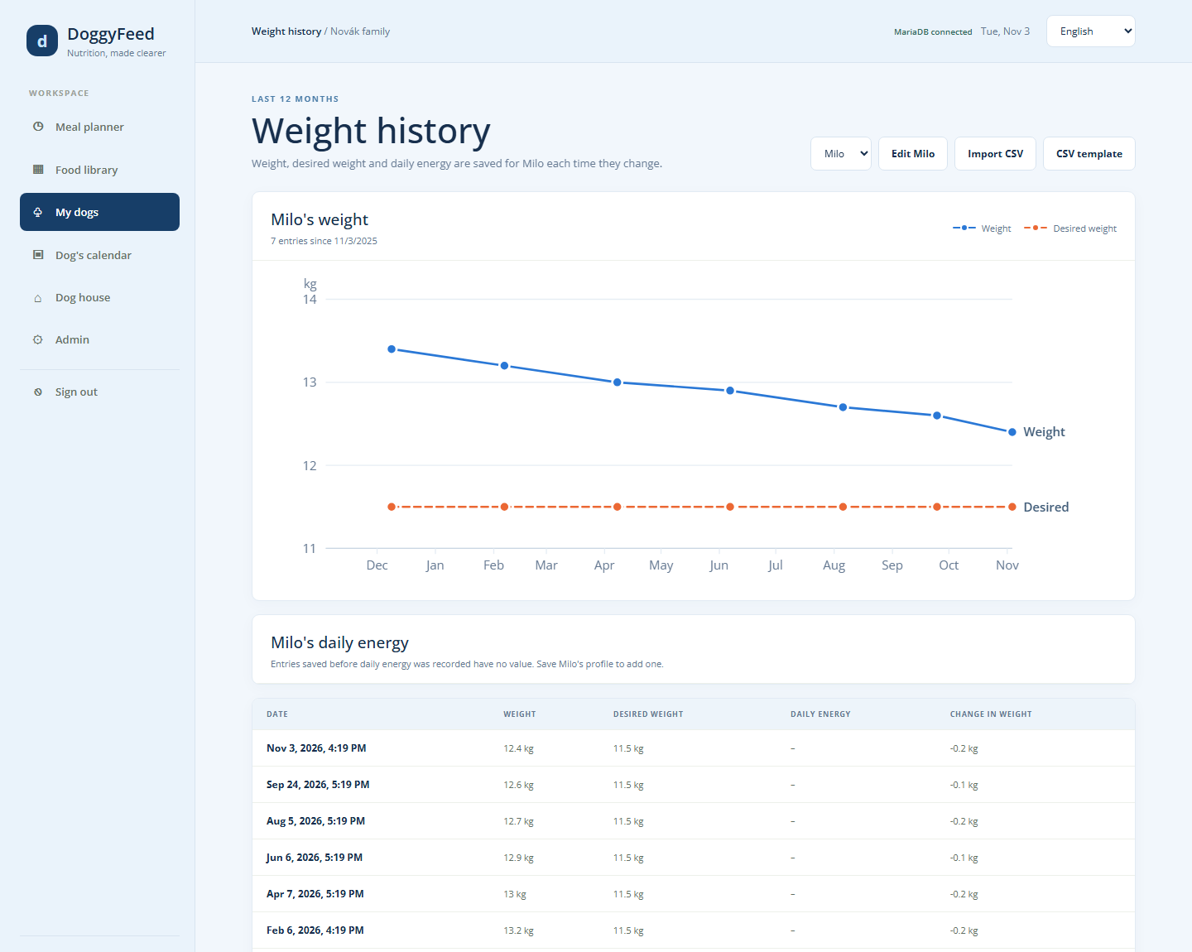
A new entry is saved every time you save a changed weight, desired weight or daily energy. The dog picker at the top switches between dogs, and Edit opens the dog's form.
Import CSV loads older history from a file; CSV template downloads an example. The file format is described in section 10.4. An imported row for a day that already has an entry replaces it.

6. Food library
The Food library lists every food your dog house uses, with its nutrition values per 100 g. The Meal planner only offers foods from this library.
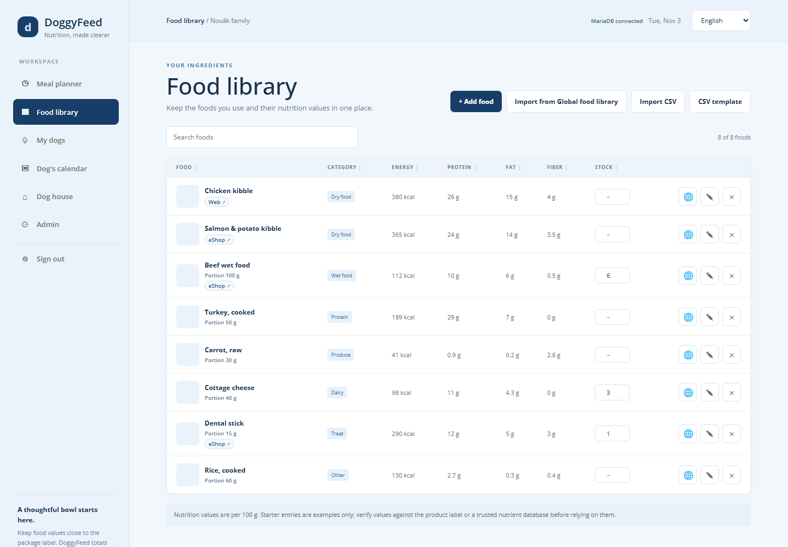

6.1 The list
- Search foods filters the list by name or category as you type.
- Click a column name to sort by it: the first click sorts ascending (▲), the next descending (▼). Foods whose stock is not tracked stay at the end.
- Web ↗ and eShop ↗ under a food's name open its manufacturer's website or shop page in a new tab.
- Row buttons: 🌐 exports the food to the Global food library (section 6.6), ✎ edits it (or double-click the row), × deletes it.

6.2 Adding or editing a food
Press + Add food, or ✎ on a food. Fill in the form and press Save.
Field | Required | Example | Notes
Food name | yes | Salmon & potato kibble | Up to 60 characters
Category | yes | Dry food | Dry food, Wet food, Protein, Produce, Dairy, Treat or Other
Food picture | no |  | JPG, PNG or WebP, up to 8 MB; shrunk before upload
Energy (kcal) per 100 g | yes | 365 | From the package (see section 10.3 for kcal/kg)
Protein, Fat, Fiber (g) per 100 g | yes | 24 / 14 / 3.5 | The "analytical constituents" on the package, in % = g per 100 g
Portion (g) | no | 100 | Amount added to a bowl at once; hidden for Dry food
Stock (pieces) | no | 6 | Empty = not tracked
Manufacturer website | no | https://www.example-petfood.com | Shown as Web ↗
eShop link | no | https://www.example-shop.com/salmon | Shown as eShop ↗ and linked from out-of-stock events
Portion. A food with a portion is added to a bowl with that amount. A food without one (always Dry food) is auto-filled to the bowl's energy target (section 4.2).

6.3 Stock
Stock counts pieces, such as cans, pouches or sticks. Type a new number in the Stock column; it is saved when you leave the field or press Enter (Escape puts the old value back). An empty field stops tracking.
- Bowl served takes the used pieces off every food that is not Dry food: grams served ÷ portion, or 1 piece for a food without a portion.
- A food at 0 is shown in red. Stock never goes below 0.
- When a food drops below 2 pieces, an event "<food> - out of stock" is added to the Dog's calendar for all dogs, linking to its eShop page. It disappears once the stock is 2 or more again.
Example. Beef wet food has a portion of 100 g and a stock of 6 cans. Luna is served a bowl with 100 g of it: the stock drops to 5.

6.4 Searching the web for a food
The Add a food form starts with Search the web for this food. Type the brand and product name and press Search.
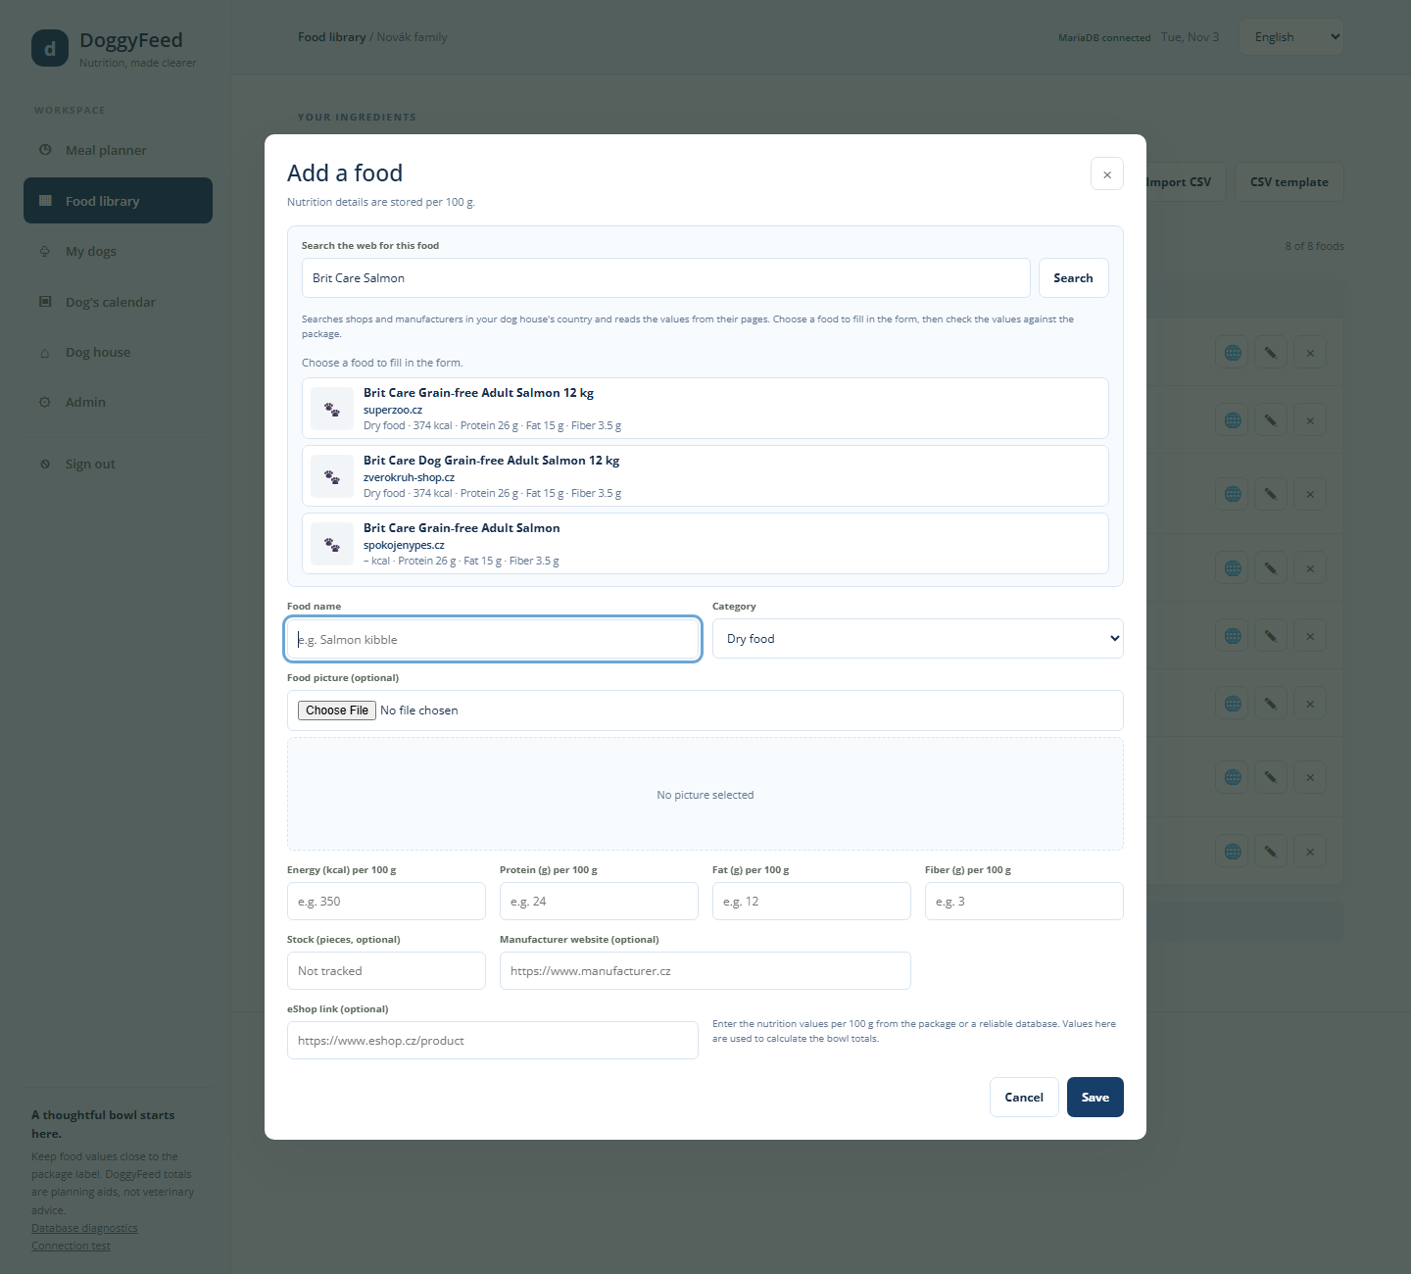
DoggyFeed searches shops and manufacturers in your dog house's country and language, and reads the values from the pages it finds. Each result shows the shop's site and the values it found; – means a value was not found. Results with more values come first.
Choosing a result fills in the name, category, energy, protein, fat, fiber, picture and eShop link. Fill in the empty values and check every value against the package before saving: shop pages can be wrong or out of date.
The web search needs a search key set up on the server (see section 11). Without it, results come from the Open Pet Food Facts database, and the form says so.

6.5 Importing foods
Import from Global food library lists foods shared by all dog houses, filtered by name, category and country. The country filter starts at your dog house's country. Tick the foods you want and press Import selected; their pictures come along. Foods already in your library are greyed out.
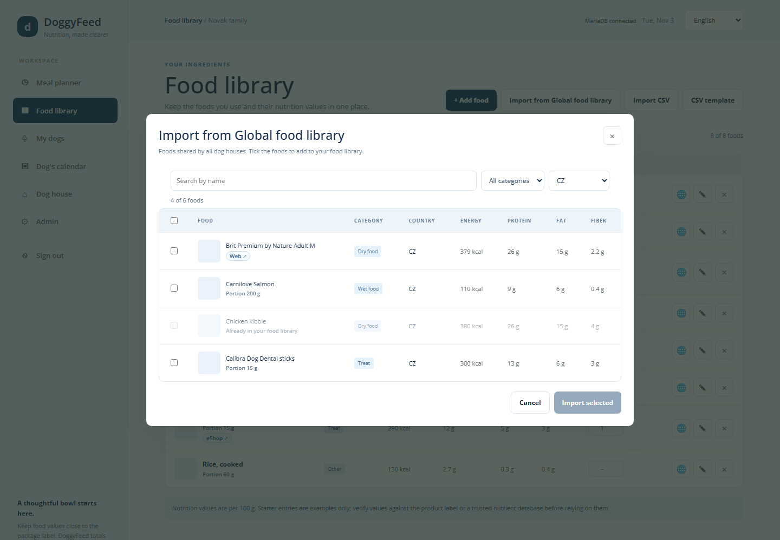
Import CSV loads foods from a CSV file; CSV template downloads an example. A row whose name matches a food in the library updates it and keeps its picture; other rows are added. The file format is in section 10.4.

6.6 Sharing a food with everyone
🌐 on a food copies it, with its picture but without its portion, to the Global food library under your dog house's country. If a food with the same name and country is already there, administrators are asked whether to replace it; other users are told it already exists.

7. Bowls history and Dog's calendar

7.1 Bowls history
Bowls history shows every bowl recorded with Bowl served, 10 days at a time. Open it with Bowls history on a dog's bowl in the Meal planner.
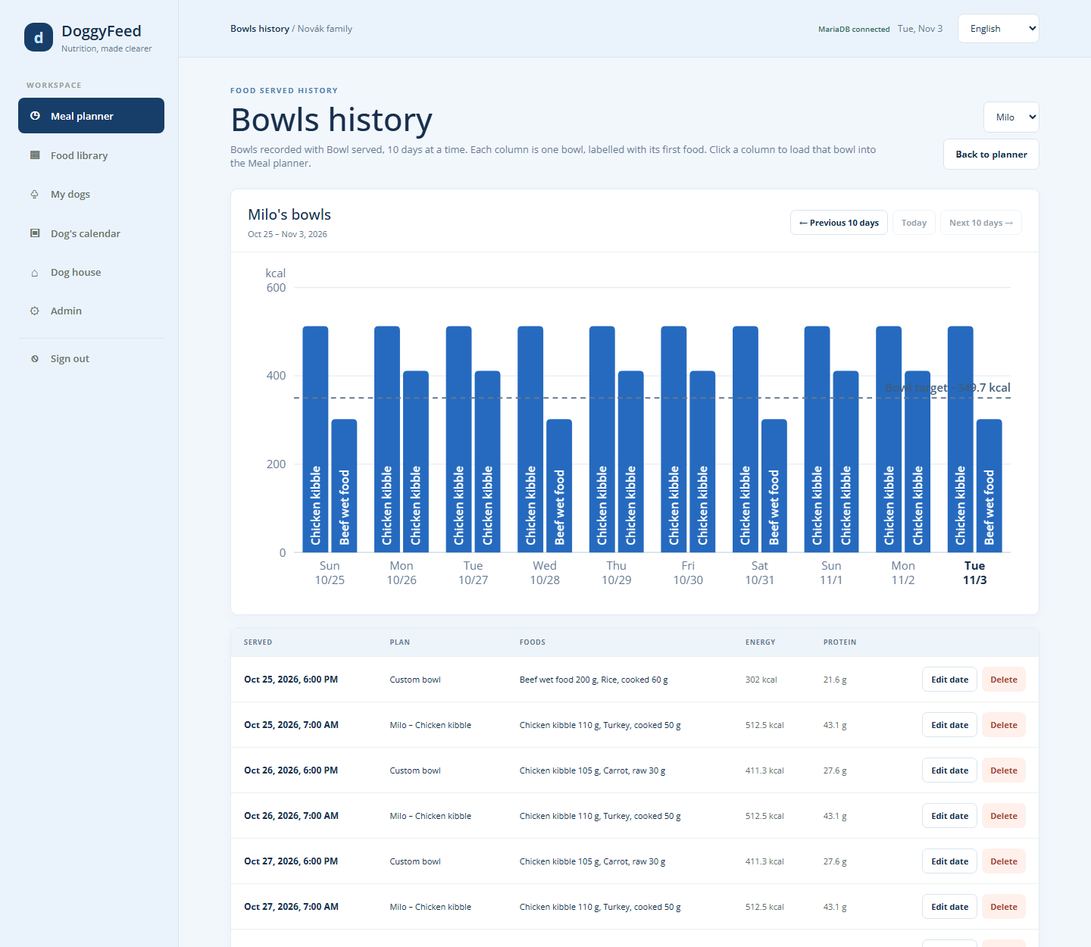
- The chart has one column per served bowl, labelled with its first food, and a dashed line at the dog's bowl target. A column well above the line means a bowl with more energy than planned.
- Click a column to load that bowl back into the Meal planner, for example to serve the same bowl again.
- The dog picker switches dogs; Previous 10 days, Today and Next 10 days move through time; Back to planner returns to the Meal planner.
- The list below shows each bowl's time, plan name, foods with amounts, energy and protein. Edit date moves a bowl to another date and time; Delete removes it. Deleting a bowl does not put its pieces back into stock.
Example. On Oct 25 Milo got two bowls: "Milo – Chicken kibble" at 7:00 AM (110 g kibble + 50 g turkey = 512.5 kcal) and a custom bowl at 6:00 PM (302 kcal). The morning bowl is 163 kcal over the 349.7 kcal target.

7.2 Dog's calendar
The Dog's calendar keeps appointments for one dog or for all dogs: vet visits, grooming, training, medication. It shows one month at a time and lists the next 30 days below.
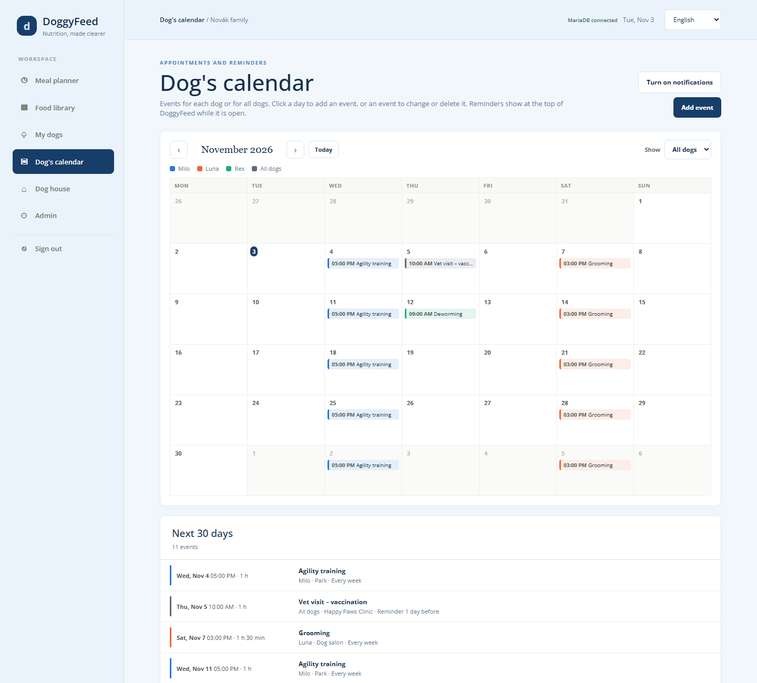
- ‹ and › change the month; Today goes back to this month.
- Show filters the events by dog. Each dog has its own colour; grey is for events for all dogs.
- Click a day to add an event on that day, or press Add event.
- Click an event to change or delete it.
- Turn on notifications lets the browser show reminders as system notifications.

7.3 Events
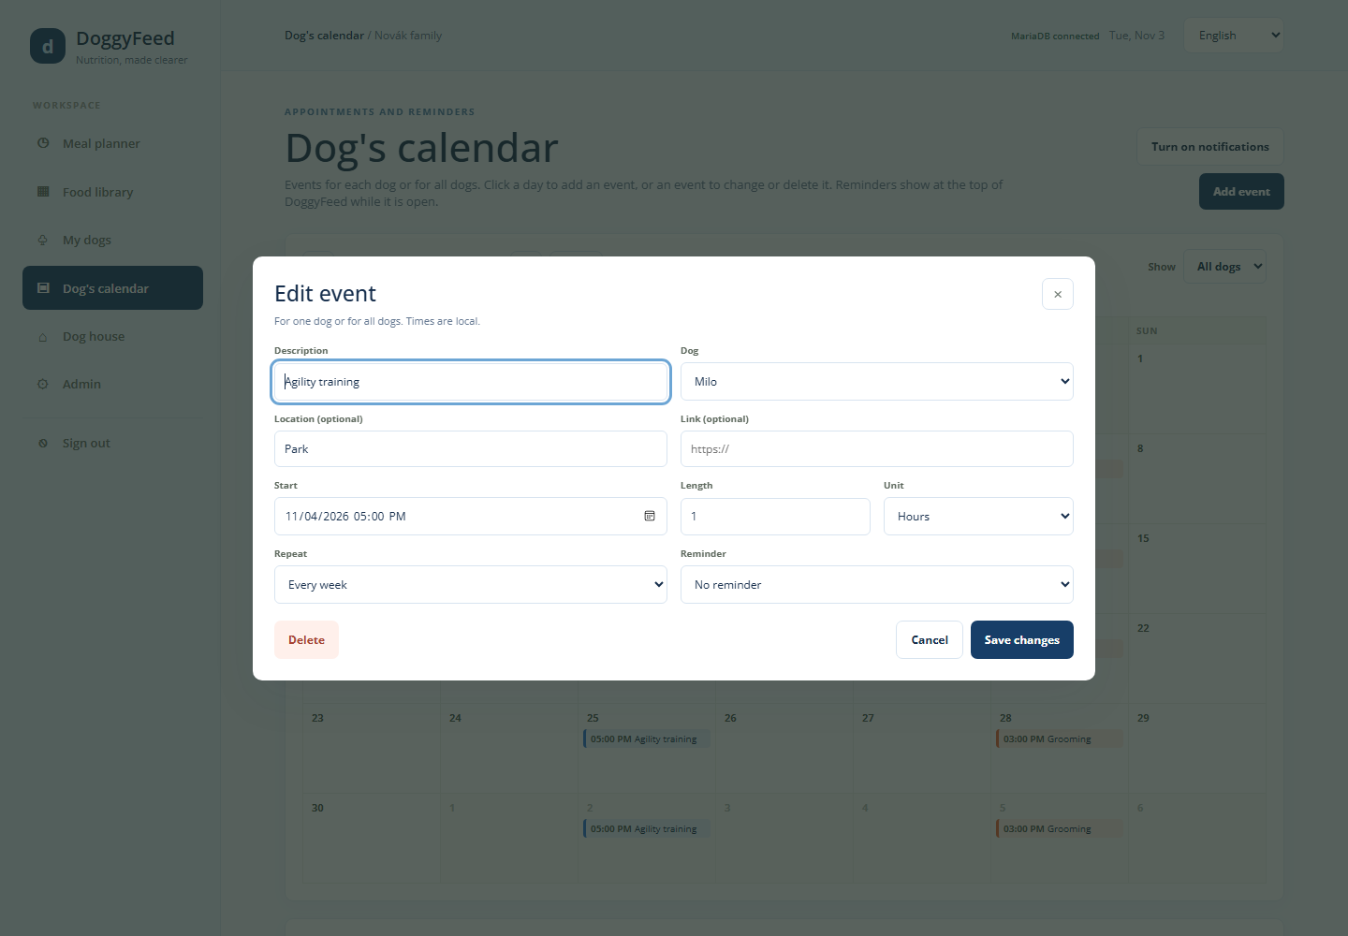
Field | Values | Example
Description | text | Vet visit – vaccination
Dog | one dog, or All dogs | All dogs
Location | optional text | Happy Paws Clinic
Link | optional web address | The clinic's booking page
Start | date and time (local time) | Thu, Nov 5, 10:00 AM
Length and Unit | number with minutes, hours or days | 1 hour
Repeat | Does not repeat, Every day, Every week, Every year, Every … days | Every week
Reminder | No reminder, 1 day, 1 week or 1 month before, … days before | 1 day before

7.4 Reminders
From the reminder time until the event starts, the event is listed in the Reminders ribbon at the top of the Meal planner and My dogs, with a button to dismiss it. Events that start today are always listed. Below what is due, the ribbon lists the next 6 upcoming events within 90 days.
When notifications are turned on, each reminder also appears once as a system notification. Reminders only appear while DoggyFeed is open, and notifications need DoggyFeed opened over https.
Out of stock. When a food's stock drops below 2 pieces, DoggyFeed adds the event "<food> - out of stock" for all dogs automatically (section 6.3).

8. Dog house
The Dog house page holds your dog house's profile and the users who share it. All its users see the same dogs, foods, plans and calendar.
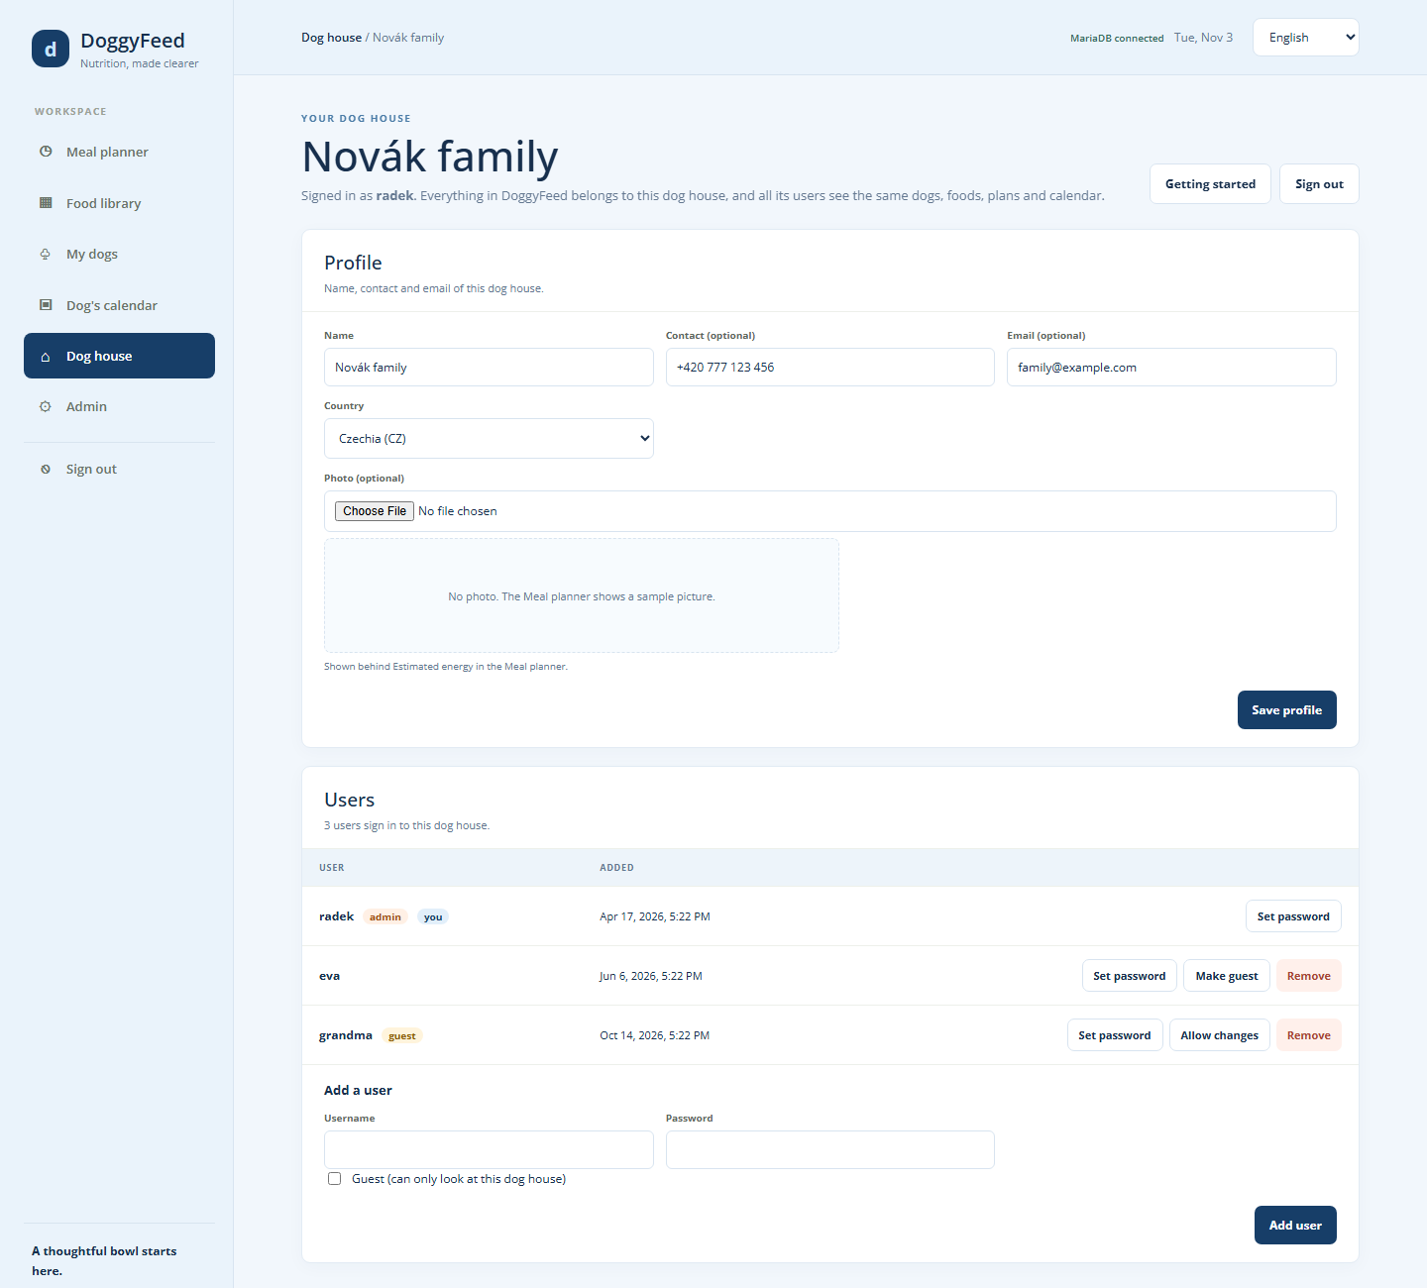

8.1 Profile
Field | Example | Notes
Name | Novák family | Shown in the top bar
Contact | +420 777 123 456 | Optional
Email | family@example.com | Optional
Country | Czechia (CZ) | Chosen from the list of countries; sets where the web food search looks and which country is pre-selected when importing from the Global food library
Photo |  | Optional; shown behind the bowl total of every dog without its own photo. Without any photo, a sample picture is shown
Press Save profile to save changes.

8.2 Users
The list shows every user of the dog house with their role (admin, guest, and you for yourself) and the date they were added.
- Add a user: type a username and password (at least 8 characters) and press Add user. Tick Guest for a user who should only look. Usernames are unique across all dog houses.
- Set password gives a user a new password. That user is signed out on all other devices.
- Make guest turns a user into a view-only guest; Allow changes turns a guest back into a normal user.
- Remove deletes the user.
Rules: nobody can change their own role or remove themselves, administrators cannot be guests, and every dog house keeps at least one user who is not a guest.
Example. To let a dog sitter check the feeding plan while you are away, add the user "sitter" with Guest ticked. They see every bowl, plan and event but cannot change anything. Remove them when you are back.

8.3 Other buttons
- Getting started opens the Welcome page with the setup steps (section 2.3).
- Sign out signs you out on this device.

9. Admin console
The Admin console manages the whole DoggyFeed server: every dog house, every user, the shared Global food library and the list of countries. Only administrators see Admin in the menu. The page has four tabs, and it remembers the last one you opened.

9.1 Dog houses
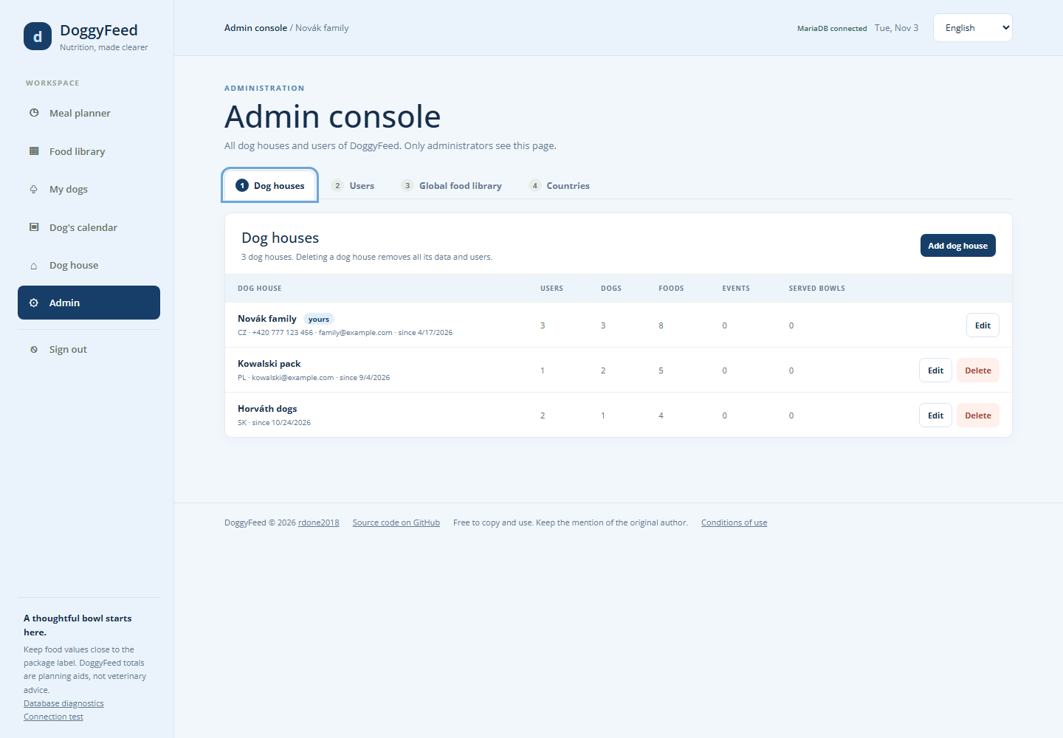
The list shows each dog house with its country, contact, start date and counts of users, dogs, foods, events and served bowls.
- Add dog house creates an empty dog house.
- Edit changes its name, contact, email and country.
- Delete removes the dog house with all its data and users, after you type its name to confirm. You cannot delete your own dog house.

9.2 Users
[image: Admin console, Users tab]
- Add user adds a user to any dog house, optionally as an administrator or a guest.
- Set password, Move (to another dog house), Make guest / Allow changes, Make admin / Remove admin and Delete.
- You cannot delete or demote yourself, and DoggyFeed always keeps at least one administrator. The user who first set up DoggyFeed is the first administrator.

9.3 Global food library
[image: Admin console, Global food library tab]
The Global food library holds foods shared by all dog houses, each with a country. Users import from it into their own Food library (section 6.5).
- Filter by name, category and country.
- Add food, or double-click a food (or ✎) to edit it, with its picture. Portion is hidden for Dry food, as in the Food library.
- × deletes one food; tick several and press Delete selected to delete them together.
- Import CSV adds or updates up to 5,000 foods at a time (format in section 10.4). A row whose name and country match an existing food updates it and keeps its picture.
- Import pictures adds pictures to foods already in the list: choose JPG, PNG or WebP files named after the foods, for example Chicken kibble.jpg. Letter case does not matter. Files that match no food are listed and skipped. Import the CSV first, then the pictures.

9.4 Countries
[image: Admin console, Countries tab]
The countries table lists every country a dog house can be in: a two-letter code (ISO 3166-1, plus XK for Kosovo) and a name, with the number of dog houses in it. Search by code or name, Add country, edit (✎) or delete (×). Changing a code also changes it for the dog houses in that country. A country with dog houses in it cannot be deleted.

9.5 Diagnostics and Connection test
Administrators see two links at the bottom of the menu:
- Database diagnostics shows the database tables, row counts and stored values, and the server's error log. It only opens on the server computer itself (http://127.0.0.1:3000/diagnostics).
- Connection test sends test requests of different sizes to the server and reports which ones arrive. Run it through the address you normally use, such as your internet domain, when saves fail there but work locally. Nothing is saved.

10. Data explanation

10.1 What DoggyFeed stores
Everything except the Global food library and the countries belongs to one dog house and is visible only to its users.
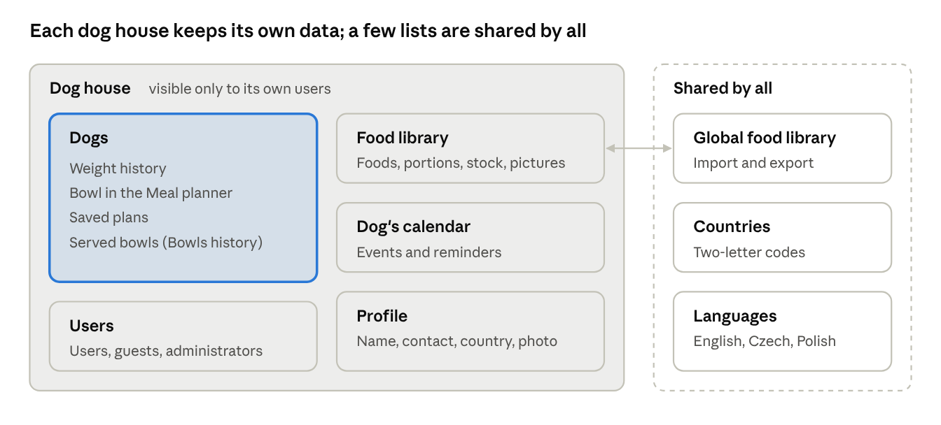
what belongs to a dog house and what is shared
Record | Belongs to | Holds
Dog house | the server | Name, contact, email, country, photo
User | a dog house | Username, password (as a secure hash only), administrator and guest flags
Dog | a dog house | Name, weight, desired weight, life stage, gender, heat dates, meals per day, custom daily energy, activity, breed, photo
Weight history entry | a dog | Date and time, weight, desired weight, daily energy, whether the energy was custom
Food | a dog house | Name, category, kcal, protein, fat, fiber per 100 g, portion, stock, manufacturer and shop links, picture
Bowl (meal item) | a dog | Food, amount in grams, auto-fill on or off
Saved plan | a dog (or any dog) | Name, foods with amounts, saved and updated dates
Served bowl | a dog | Time served, plan name, target, each food's name, amount and values at that moment
Calendar event | a dog or all dogs | Description, location, link, start, length, repeat, reminder
Global food | the server | Like a food, plus a country, without stock
Country | the server | Two-letter code and name
Language and translation | the server | Page texts in English, Czech and Polish
A served bowl keeps a copy of each food's values, so Bowls history stays correct even after you change or delete the food.

10.2 Units
Value | Unit
Weight, desired weight | kilograms (kg)
Energy of a food | kcal per 100 g
Protein, fat, fiber of a food | grams per 100 g (the same number as % on the package)
Amounts in a bowl, portion | grams (g)
Daily energy, bowl target | kcal
Stock | pieces (cans, pouches, sticks, bags)

10.3 Calculations
Bowl totals. For each food in the bowl, its values are scaled by the amount:
\text{energy of a food in the bowl} = \frac{\text{amount (g)} \times \text{kcal per 100 g}}{100}
Protein, fat and fiber are scaled the same way. The bowl total is the sum over all foods; the percentage is the bowl total divided by the bowl target.
Example. 50 g of Turkey, cooked (189 kcal, 29 g protein per 100 g) gives 50 × 189 ÷ 100 = 94.5 kcal and 14.5 g protein.
Daily energy and bowl target. See section 5.2: 70 × weight^0.75 × activity factor, or the custom daily energy, divided by the meals per day.
Reading a package. Pet food packages list values in different ways. Convert them before typing them in:
On the package | Type in DoggyFeed | Example
Energy in kcal/100 g | the same number | 374 kcal/100 g → 374
Energy in kcal/kg | divide by 10 | 3,740 kcal/kg → 374
Energy in MJ/kg | multiply by 23.9 | 15.6 MJ/kg → 373
Crude protein, crude fat, crude fibre in % | the same number, in grams | Crude protein 26 % → 26
Stock. Each Bowl served takes off grams ÷ portion pieces for every food that is not Dry food, or 1 piece for a food without a portion.

10.4 CSV file formats
CSV files are plain text tables, one row per record, with a header row naming the columns. Comma, semicolon or tab separators are accepted, and decimal commas work. Every import page has a CSV template button that downloads the example below.
Food library (Import CSV). name and kcal are required; the other columns are optional. A row whose name matches a food updates it. Unknown categories become Other. An empty portion, stock or link clears that value; a file without the column keeps existing values.
name,category,kcal,protein,fat,fiber,portion,stock,manufacturer_url,shop_url
Salmon kibble,Dry food,365,24,14,3.5,,,https://www.example.com,https://shop.example.com/salmon-kibble
Chicken in jelly pouch,Wet food,85,9,4.5,0.3,100,24,,
Carrot raw,Produce,41,0.9,0.2,2.8,40,,,
Global food library (administrators). Like the food library, plus country (a two-letter code) and without stock. A row whose name and country match a global food updates it. At most 5,000 rows per file.
name,category,country,kcal,protein,fat,fiber,portion,manufacturer_url,shop_url
Salmon kibble,Dry food,CZ,365,24,14,3.5,,https://www.example.com,https://shop.example.com/salmon-kibble
Chicken in jelly pouch,Wet food,DE,85,9,4.5,0.3,100,,
Weight history. date and weight are required. Dates can be YYYY-MM-DD or DD.MM.YYYY, optionally with a time. daily_energy_custom is yes or no. A row for a day that already has an entry replaces it.
date,weight,desired_weight,daily_energy,daily_energy_custom
2026-01-15,12.4,11.5,,
2026-02-15,12.1,11.5,650,yes
2026-03-15 08:30,11.9,11.5,620,yes

11. Troubleshooting and FAQ
Problem | Cause | What to do
Banner "Changes were made somewhere else" | The dog house was changed on another device or tab at nearly the same moment | Load the latest data to see the newest version, or Save my version anyway to keep yours. Close DoggyFeed in tabs you are not using.
Status "Browser storage only" or "Database save failed" | The page cannot reach the DoggyFeed server | Check your internet connection and reload. Changes made meanwhile are kept only in this browser.
"The DoggyFeed server did not answer within 30 seconds" | A proxy or network between you and the server holds back the save | An administrator runs the Connection test through the same address (section 9.5). Behind nginx, allow bodies of at least 20 MB (client_max_body_size 20m;).
Banner "Restart the DoggyFeed server" | The server files were updated but the server was not restarted | Whoever runs the server restarts it.
Web search says the foods come from Open Pet Food Facts | No web search key is set on the server | Add TINYFISH_API_KEY=<key> to the server's env file (/etc/doggyfeed/doggyfeed.env) and restart. Keys come from agent.tinyfish.ai.
Web search results have missing values (–) | The shop page does not list them | Choose a result with more values, or type the values from the package.
No system notifications for reminders | Notifications are off, or DoggyFeed is not opened over https | Press Turn on notifications in the Dog's calendar and allow them in the browser. Reminders always show in the ribbon while DoggyFeed is open.
Sign-in says to wait and try again | Too many failed sign-ins from your address or for your username | Wait the time shown, then try again with the right password.
Forgotten password |  | Another user of your dog house sets a new one with Set password on the Dog house page, or an administrator does it on the Admin page.
Buttons are missing and fields cannot be changed | You are signed in as a guest | Ask a user of the dog house to press Allow changes for you.
A food is missing from "Choose from food library" | Only Food library foods are offered | Add it to the Food library first (section 6).
A text is in English although another language is chosen | That text has no translation yet | It is translated in a later version; the function works the same.
Can I use DoggyFeed on my phone? Yes. The page adapts to small screens: the menu becomes a row of tabs and the bowls are shown one under another.
Can two people feed the dogs from two phones? Yes. Both sign in to the same dog house. Each page loads the other's changes within 30 seconds, or at once when it is opened again.
Does deleting a food change my history? No. Served bowls keep their own copy of each food's values.
Is DoggyFeed free? Yes. It is open source under the MIT License: free to copy, use, change and share, as long as the copyright notice naming the original author, rdone2018, is kept. Source code: github.com/rdone2018/DoggyFeed.

